Cover page
Acknowledgment
This work would have not been possible without funding from The Coronavirus Aid, Relief, and Economic Security (CARES) Act, approved by the Fresno County Board of Supervisors and the City of Fresno Council. We extend our appreciation to all the community-based organizations that were involved in the COVID-19 Equity Project. We are extremely grateful to the community health workers who were at the forefront of this pandemic risking their health and safety. We also thank all community members who trusted the CEP staff and allowed them to be part of their health care team.

The authors would like to thank Tishanna Dillard and Evelyn Barajas from Fresno Building Healthy Communities and Cid and Macedo, Inc. for their outstanding talent they exercised to graphically design this work.
TOC
Executive summary
Black, Indigenous, and Communities of Color have been disproportionately impacted by the COVID-19 pandemic. These communities are more likely to experience negative social determinants of health such as lower socioeconomic status, poorer working conditions, lack of access to health care, and worse living conditions, including housing and built environment, all of which contribute to higher rates of underlying medical conditions and increased risk of contracting the virus, being hospitalized, and dying from COVID-19. While many healthcare practitioners have incorporated cultural competence models, many medically underserved communities do not have access to those services. Community Health Workers (CHWs) play a crucial role in connecting those communities to vital healthcare services. Latinx, immigrants and refugees, Black/African Americans, people with disabilities, and residents of rural areas are among some of the communities that can benefit from programs that utilize the Community Health Worker (CHW) Model.
The Community Health Worker Model
The CHW Model has been implemented in many countries for decades to help prevent various infectious diseases transmission such as Ebola and Zika. CHWs are trained lay persons who can assist in the communication of health information and coordination of health services, particularly in medically underserved or remote communities. They have also played an important role in combating the COVID-19 pandemic. Fresno County has been heavily impacted by the pandemic with a total of 95,393 reported cases and 1,443 related deaths, as of February 2021. In May 2020, the Immigrant Refugee Coalition (IRC), established almost a decade ago, and African American Coalition (AAC), established in response to the pandemic, proposed a neighborhood-based approach to the local health department in Fresno County and City of Fresno to help minimize the spread of COVID-19 in the county among the most medically underserved communities. The neighborhood-based approach would use the CHW model to provide prevention education, contact tracing, and coordination of social services support to culturally and linguistically diverse communities.
Fresno COVID-19 Equity Project
In September 2020, the COVID-19 Equity Project (CEP) was officially launched based on the suggested framework that the IRC and AAC presented. Both coalitions were involved in the implementation of the project. Four months later a third coalition joined; the Disability Equity project (DEP) which was formed in response to the pandemic to serve the needs of people with disabilities. Each coalition is composed of several trusted community-based organizations that have experience in employing CHWs. The three coalitions collaborated with the local health department, health institutions and other community partners to implement the CEP focus areas: 1) health education and outreach, 2) contact tracing, and 3) coordination of the isolation and quarantine support.
Collective Impact
The CEP project helped build the capacity of the involved organizations to respond to the pandemic by providing training to their employed CHWs, collaborating with health institutions and community partners, and navigating the logistics of large-scale programming.
The coalitions were successful in reaching populations who face language, cultural, geographic, or disability barriers in accessing healthcare. Because the coalitions had built trust between themselves and the communities they serve, they were able to quickly respond to the needs of the community: coordinating food and Personal Protective Equipment (PPE) distribution events, hosting hundreds of COVID-19 testing events, and recently, vaccination events that prioritized the most vulnerable such as farmworkers and residents of rural areas.
Challenges and Opportunities
While implementing this project, the coalitions and the involved organizations have faced several challenges that include:
1. The dynamic nature of the COVID-19 pandemic that required staff to continuously be updated and informed about the evolving local and national guidelines and recommendations.
2. Handling the logistics related to large-scale programming
3. The ability to prioritize provision of resources to communities in need with the limited availability of resources
4. The lack of accessible health information and training materials for the people with disabilities, blind, and d/Deaf people
5. The unavailability of disaggregated racial/ethnic data categories that can assist staff to accurately collect the demographics of communities served
6. The lack of sustainable funding that would keep those organizations onboard.
The CHW model is uniquely positioned to mobilize and be at the forefront of any future phases of the COVID-19 pandemic. The pandemic has demonstrated that our healthcare system has significant limitations in addressing the needs of remote and rural communities as well as Black, Indigenous, and People of Color. Many of these communities have distrusted the healthcare system because of the historical trauma and persisting discrimination. There is a need to acknowledge the historical traumas and their resulting harms for some populations as a foundational step in building communities’ trust with the medical community. Inviting voices of the disproportionately impacted communities in the initial phases of planning large-scale programming is essential to ensure their representation. The disaggregation of racial/ethnic demographic data continues to be a barrier which makes it difficult to clearly identify how subgroups are impacted by health emergencies and limits the ability to provide resources to communities that are most in need.
It is crucial to build on the relationships and collaboration between CHWs, community-based organizations, and health institutions. A sustained investment is needed in the CHW workforce to keep them trained and equipped to timely respond to any health emergencies. The CEP partnering coalitions have demonstrated that a neighborhood approach to care can better meet the needs of communities served in a more timely manner.
Background
Disparities in COVID-19 Prevalence and Outcomes Among Marginalized Communities
Black, Indigenous, and Communities of Color have been disproportionately impacted by the COVID-19 pandemic. Their social determinants of health such as income level, occupation, access to health care, and living conditions, which includes housing and built environment, contribute to higher rates of underlying medical conditions and increase their risk of contracting the virus, being hospitalized, and dying from COVID-19 (Centers for Disease Control and Prevention [CDC], 2021). Many Black, Indigenous, and People of Color encounter numerous structural barriers which lower their social determinants of health and impact their ability to lead a healthy life economically, physically, and mentally.
Federal data shows that Black/African American and Latinx communities are three times more likely to contract the virus and nearly twice as likely to die from COVID-19 than white people. (Wen & Sadeghi, 2020). In the same state where Latinx comprise almost 39% of the population, they account for 55% of all cases and 46% of the deaths (California Department of Public Health [CDPH], 2021). While white people make up approximately 37% of the CA population and only 20% of cases and 31% of deaths, the African American makes up 6% of the population but is approximately 4% of cases and 7% of deaths (CDPH, 2021).
In counties with higher numbers of racially and ethnically diverse people, especially with high levels of residential segregation between white people and Communities of Color, there are higher numbers of confirmed cases among racially marginalized groups (Yang et al., 2021). Percentages also vary among each race category by age group. For instance, for the 0-17 age group, the Native Hawaiian and Pacific Islander forms about 0.3% of CA population and have 7% of percentage of deaths due to COVID-19 (CDPH, 2021). Another example of troubling disparity is among the 18-49 age group where Latinx comprise approximately 43% of the CA population of this age group and 72% of deaths (CDPH, 2021).
In addition to Black, Indigenous, and People of Color, people with disabilities have also been disproportionately impacted by the COVID-19 pandemic (Sabatello et al., 2020). In the United States, one in four people have a disability or disabilities (Okoro et al., 2018). During the pandemic, people with disabilities have encountered numerous structural barriers including rationing of ventilators for people with disabilities and lack of resource allocation (King, 2020). Grote and Izagaren (2020), two deaf doctors in the United Kingdom have highlighted the communication needs of the d/Deaf community in healthcare settings such as the unavailability of suitable transparent masks which allow for easier communication and the limitations of written notes as the grammatical structures of many signed languages are different from their spoken counterparts. In 2021, the Los Angeles Times reported that many government information and vaccination websites were inaccessible and violated disability rights laws (Weber & Recht, 2021). The inaccessibility of the sites resulted in many Blind and low vision people being unable to register for vaccination appointments online (Weber & Recht, 2021). The pandemic has highlighted the ways in which people with disabilities were overlooked and under-prioritized which has had devastating and deadly consequences (Sabatello et al., 2020).

COVID-19 in Fresno County, California
Fresno County is the largest county in the San Joaquin Valley in California. Latinx people are 54% of the population and Black/African American people are 6% of the population (U.S. Census Bureau, 2019). Fresno County also has one of the highest Hmong populations in the nation. Thirteen percent of the county population has a disability (UCSF, n.d.). The median household income is $54,000 and 20% of the population live in poverty, compared to $ 63,000 and 11% in CA respectively. Forty-four percent of Fresnans 5 years and older live in a household where there is another language than English spoken at home (U.S. Census Bureau, 2019).
The COVID-19 Community Vulnerability Index (CCVI) is an indicator, on a scale from 0-1, that can show how and why communities are vulnerable to the pandemic. Identifying this index aims at developing solutions to better plan, prepare, and respond to the pandemic. Fresno County scored 0.93 (Emory University, n.d.) which indicates a very high vulnerability to have worse health, economic, and social outcomes of the pandemic. According to the CDC social vulnerability index data 2018 database, Fresno County also scored very high on socioeconomic vulnerability (0.9), minority/language vulnerability (1.0), and housing/transportation vulnerability (0.8), which all range from 0-1.0. (Emory University, n.d.) As of February 2021, Fresno County had a total of 95,393 reported cases and 1,443 deaths related to COVID-19 (FDCPH, 2021).
Data from the Fresno County Department of Public Health (2021) shows that Latinx comprise 45% of all confirmed cases, have the highest number of COVID-19 related deaths among all races/ethnicities, and have the highest number of individuals who died from COVID-19 under the age of 65 year. There is no data available on deaths of those with disabilities. Starting from June 2020, COVID-19 incidence has increased in some rural communities such as Selma, Sanger, Reedley, and Parlier (FDCPH, 2021). The cumulative reported cases per 10,000 residents are highest in rural areas where the majority of residents are Latinx (see Figure 1 and 2).
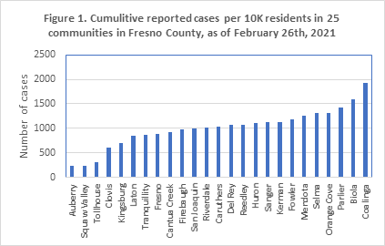
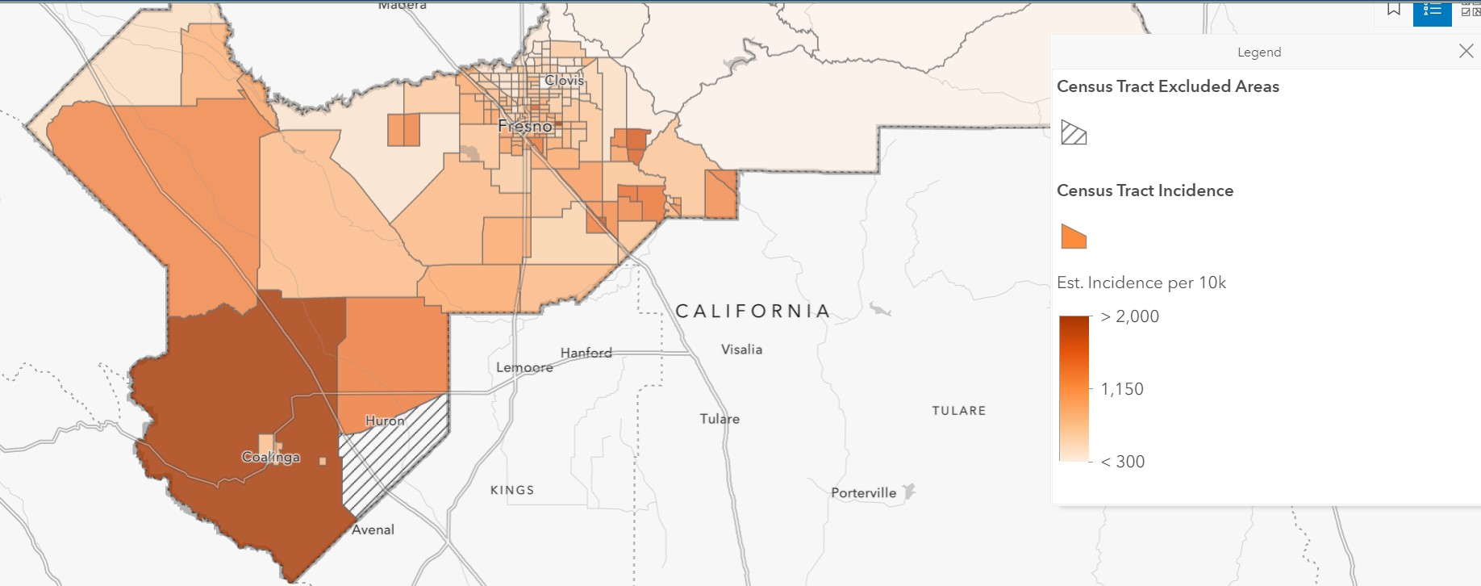
Figure 2. A map showing the distribution of COVID-19 cases in the county as of February 2021.
Data source: Fresno County data hub https://www.co.fresno.ca.us/departments/public-health/covid-19/covid-19-data

This white paper discusses the implementation process of the COVID-19 Equity Project as an example of collaboration between community-based organizations (CBOs) in the City of Fresno and the local health department in Fresno County. Using a neighborhood-based approach, the community health workers model was utilized to help mitigate the COVID-19 transmission in the county. This work will provide a high-level overview of the successes and challenges that the CBOs had and some suggestions to address those challenges.

Community Health Workers Model Serving the Hard-to-Reach Populations
Inaccessibility of health information related to COVID-19 transmission, infection prevention, symptoms, and testing resources can increase the likelihood of COVID-19 spread in culturally and linguistically diverse communities. Many surveys have shown that Black/African American and Latinx populations are less likely to have access to information about best practices to prevent COVID-19 transmission than their white counterparts. (Alsan et al., 2020, Calo et al., 2020) Additionally, communities of color have experienced historical and persisting medical racism and trauma which has resulted in mistrust of medical professionals and the healthcare system (Jones et al., 2020).
Community health workers (CHWs) are trained lay persons who can assist in the communication of health information and coordination of health services, particularly in underserved or remote communities. CHWs are “typically frontline workers who are trusted members of and/or have a unique and intimate understanding of the communities they serve” (National Academy for State and Health Policy, 2019) and “community members who work almost exclusively in community settings… to promote health among groups that have traditionally lacked access to adequate care” (Witmer et al., 1995, p. 1055). These groups include Black, Indigenous, and People of Color, low income individuals and families, migrant and farm workers, people with disabilities, unhoused community members, and other medically disenfranchised communities. In Spanish-speaking communities, CHWs are known as promotores de salud. CHWs have the capabilities to provide culturally and linguistically responsive health education and case management services (Elrick, 2017).

The CHW model is not unique to the United States and has existed in many countries for decades (Bhutta et al., 2010). The model has been utilized globally to mitigate various infectious diseases and to manage chronic diseases. Bhutta et al. (2010) examined the impact of CHW programs in Saharan Africa, South East Asia and Latin America. They found that CHW programs offered a wide range of services that included counseling on breastfeeding, targeted preventive health education, and mental health services (Bhutta, 2010).

Most recently, CWH models have been utilized to address the COVID-19 pandemic in marginalized communities. Calo et al. (2020) discuss mobilizing Better Together REACH, an existing chronic disease prevention program which works with Latinx communities of Lebanon and Reading in Pennsylvania, during the COVID-19 pandemic. Using CHWs, the program disseminated materials in Spanish, helped families stay informed about best practices to reduce the spread of the disease, provided information about testing and healthcare, and partnered with Penn State Project ECHO “to inform health care providers and administrators of the latest best practices in emergency preparedness and patient treatment of COVID-19” (p. 3). Programs such as Better Together REACH highlight the importance of CHWs and CHW models in combating COVID-19. Because they had already established existing relationships with community members, they were able to quickly mobilize to respond to the pandemic and were uniquely positioned to address specific needs in the communities they served.
Community leaders and community-based organizations, that represent the most vulnerable groups, are essential voices that need to be engaged to respond to pandemics and other emergency situations. The multi-sector collaboration between those trusted groups and the health institutions is crucial to promote community resilience and to timely connect high-risk populations to support services.
Since 2009, Central Valley Health Policy Institute (CVHPI) has highlighted the important role of promotores and CHWs in improving access to healthcare for immigrant families in Fresno County (Capitman et al., 2009). In 2017, CVHPI partnered with Fresno Building Healthy Communities (Fresno BHC) to continue strategizing how to address health inequities in South Fresno. Many residents in South Fresno are People of Color and low income. CVHPI and Fresno BHC asked community members about their perceptions of existing health challenges and their recommendations for addressing these challenges. This collaboration yielded to publishing the “Community Benefits Needs Assessment in South Fresno,” a report detailing their findings and recommendations which was presented to members of the community (Pacheco-Werner et al., 2017). One of the main recommendations from community members was the establishment of a Neighborhood Wellness Team that can provide informal, and culturally and linguistically responsive preventive and care access coordination services to a prioritized group of residents living within a designated geographical area to address comprehensive needs in a coordinated way. Another recommendation was the need to receive health services in places where community members frequent such as community centers and schools within their neighborhoods. The recommendations focused on building neighborhood level public health infrastructure.
CVHPI and Fresno BHC further developed the Neighborhood Wellness Team concept by reaching out to medical and allied health training programs, local non-profit hospital systems, and other medical providers and stakeholders. Saint Agnes Medical Center joined CVHPI and Fresno BHC in convening a broader group of stakeholders, including the Fresno County Department of Public Health. From 2017-2018, the group met over several months to develop a pilot and implementation plan. Two neighborhoods were selected to pilot the model: Calwa and Mosqueda. Saint Agnes abruptly exited the planning process and the project was never piloted. CVHPI and Fresno BHC continued to refine and submit the model to philanthropic, government, and hospital systems. The 2017 Community Benefits Needs Assessment in South Fresno and the Neighborhood Wellness Team model were foundational in shaping the structure of the Fresno COVID-19 Equity Project.
Process of Fresno COVID-19 Equity Project (CEP) development and Launch
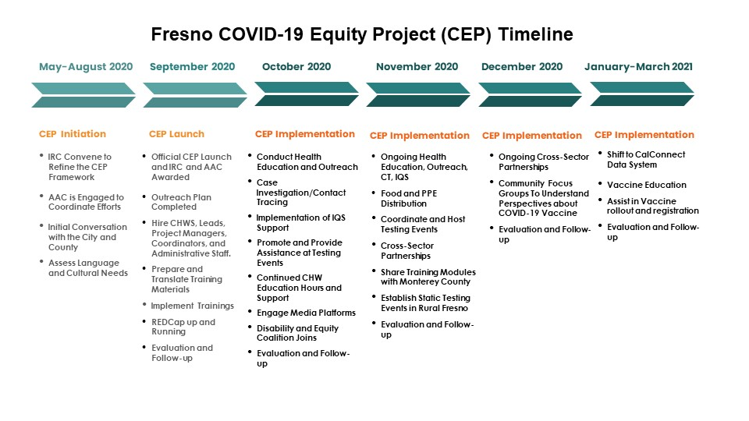
In April 2020, the Immigrant Refugee Coalition (IRC), established almost a decade ago, was keenly aware of the community's need for a neighborhood level approach to help mitigate the COVID-19 virus transmission. The organizations within the IRC quickly functioned as a COVID-19 response team and started to coordinate needed services for the impacted communities such as food distribution, financial support, education, among others. The Coalition then developed the COVID-19 Equity Project framework - based on the CHW model and the Neighborhood Wellness Team approach - to provide prevention education, contact tracing, direct social services support, and connect community members to COVID-19 testing to help minimize the spread of COVID-19 in the county. The IRC began meeting with the African American Coalition (AAC), established in response to the pandemic, to coordinate the activities already underway by each coalition, support each other's efforts, and further refine the COVID-19 Equity Project framework. In May 2020, the IRC and AAC, initiated the conversation with the local health department in Fresno County and City of Fresno Council to share the COVID-19 Equity Project (CEP) vision of how to implement this neighborhood approach in the county. The City of Fresno and Fresno County expressed interest in supporting the project and awarded the Immigrant Refugee Coalition and African American Coalition contracts to implement the CEP in August 2020 that was officially launched in September 2020. Four months later, the Disability Equity Coalition (DEP), established in response to the pandemic, joined the project to provide support for people with disabilities (see Figure 3 is an illustration of the CEP timeline). Each coalition is composed of a group of well-trusted community-based organizations (CBOs) that have experience utilizing the promotora or CHW model in their work and have established meaningful relationships with the communities each represents (refer to Appendix A for the list of partnering CBOs and their respective coalition).

Backbone Support

Developing and Delivering the Community Health Workers Training Curriculum
With the initiation of the CEP, CVHPI and Fresno BHC collaborated and developed the COVID-19 Training Curriculum (based on the Promotora model) to equip CHWs with essential skills to perform contact tracing, health education and outreach, and connecting residents to isolation and quarantine support and other services. The training focused on: information on COVID-19 and modes of transmission, infection control and proper use of Personal Protective Equipment (PPE), contact tracing and REDCap database management, Health Insurance Portability and Accountability Act (HIPAA) to ensure health information privacy protection, technology basics, and local social support resources. After the Pfizer and Moderna vaccines received the Emergency Use Authorization (EUA) from the Food and Drug Administration in January 2021, CVHPI offered a training module on COVID-19 vaccines. All training modules were translated to Spanish and made available for Spanish-speaking staff.
All modules were developed in a way that ensured participants’ engagement and interaction throughout the sessions with allotted time for open discussions and sharing experiences. Participants learned about and practiced some essential communication skills during the training such as cultural sensitivity, motivational interviewing, and ethical guidelines for group discussions. The training sessions were recorded and made available for CHWs for later use. CVHPI coordinated for two additional training sessions around Motivational Interviewing with Vision y Compromiso and Changes to Labor Rights webinar presented by representatives of the US Department of Labor.
Upon the completion of each training, the participants were invited to respond to a short survey to: (1) assess confidence in sharing information they learned within their communities; and (2) identify areas for further training. Survey results revealed the need for ongoing educational opportunities and troubleshooting support. To address these needs, CVHPI started offering “office hours” four times a week. Each office hour session addressed a specific topic: (1) contact tracing; (2) isolation and quarantine support; and (3) support on REDCap and CalConnect data systems. Over time, office hours expanded to include updates on changing COVID-19 related recommendations and guidelines. These hours also functioned as opportunities to respond to the learning needs of CHWs and their leads. For example, following the Janssen Vaccine EUA approval, CHWs received training on the new vaccine which addressed the differences between Janssen, Moderna, and Pfizer. This equipped CHWs with the information they needed to address questions in their communities about the new vaccine and to address misconceptions.
To further ensure the continuous access to updated information, the CVHPI and IRC host a weekly call in Spanish with the community members where stakeholders are invited to give updates related to the pandemic and share announcements about available resources. To respond to a community expressed need, CVHPI produced a resource list document that has been continuously updated. The list of resources includes financial, social, and other assistance related to housing, healthcare services, and immigration.
CVHPI also created the Fresno County COVID-19 Equity Project (CEP) Facebook page where upcoming resources were announced. CVHPI and Fresno BHC administrate the page and regularly post information about free COVID-19 testing events, programs available to cover cost of rent/mortgage and utility bills, workers protections, local health department COVID-19 updates and guidelines, and, most recently, free COVID-19 vaccination events.
CEP Collective Impact
Outreach, Education, and Coordination of Services
According to the submitted monthly report, the COVID-19 Equity Project reached nearly six thousand underserved Fresno residents from September 2020 to February 2021 (figure 1). Residents had the opportunity to receive assistance through more than one aspect (contact tracing, referral for isolation and quarantine support, and community outreach). The community outreach and education were the most provided services followed by contact tracing, then referral to IQS.
The community outreach efforts included COVID-19 transmission education which was the resource most utilized by the community, followed by information about COVID-19 testing and food distribution as shown in figure 2. The CHWs delivered food to the target populations through mass food drive events and home deliveries for elders. They coordinated testing events held at areas that are convenient for community members to reach. Their outreach efforts effectively bridged health literacy and healthcare access gaps faced by underserved communities.
“Community Health Workers are the heart of the COVID-19 Equity Project. Our Ethos for testing site outreach is ’I'll see you there’ or ‘alli nos vemos.’ What does this mean? When a CHW is doing outreach for a specific site, they are able to say, ’If you want or need to get testing, there's this event happening tomorrow, I'll be there, so if you need anything, I'll be there to support. I'll see you there.’ The same CHW is actually at the event to help folks as they arrive. If the person tests positive, the same CHW is the one doing the contact tracing with them, in the language they feel most comfortable speaking.” Dr Tania Pacheco-Werner, Co-Director CVHPI.
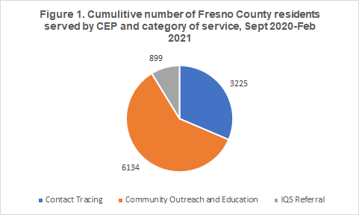

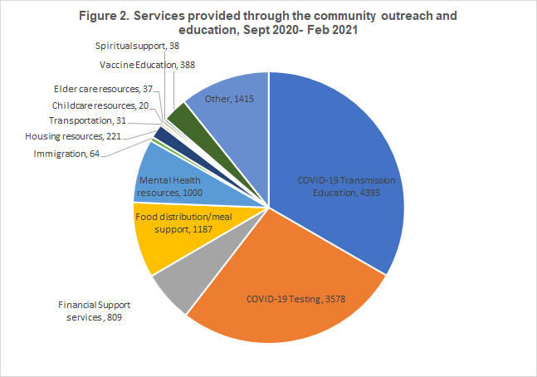

Isolation and Quarantine Support

The isolation and quarantine support (IQS) program has been the first of its kind implemented in the Central Valley. The premise is that if individuals are positive or are given a health officer order to quarantine because they have been exposed, they should be able to do so without fearing the loss of a paycheck or missed utility bill or rent payment. To date, nearly 900 households have benefited from the IQS program. This program was developed in conjunction with the Fresno County Department of Public Health,, Iin order to ensure transparency and accountability, the documentation is subject to monthly auditing. These payments assisted residents in meeting their needs; aid dispensed was mostly utilized to pay their rent or mortgage, utility and water assistance, food, among others as shown in figure 3. From September 2020 to February 2021, CEP has provided a grand total of $1,123,742.57 to 899 local individuals. This process has been a testament to the way that CHWs can provide immediate, relevant help for those that need it in a way that fits within institutional rigor.

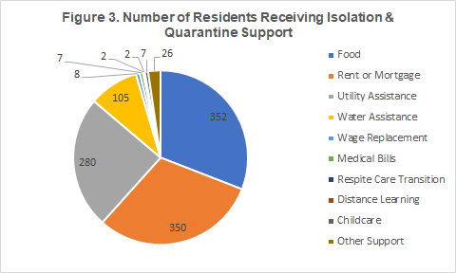

Case study
Fresno CEP’s collaboration between the city, health department, health institutions, and CBOs revolved around four main goals: 1) to provide education and outreach; 2) to perform contact tracing and case investigations; 3) to coordinate Isolation and Quarantine Support (IQS) services; and 4) to connect people to testing and vaccination services. Engaging the three partnering coalitions brought in several local CBOs that have strong ties and well-established connections with the communities they serve. Each coalition provided pathways to employment and professional development for members of the community.
Two of the coalitions, the African American Coalition and the Immigrant Refugee Coalition, existed prior to the start of the pandemic while the Disability Equity Project emerged in response to the pandemic to meet the unique needs of the Deaf, Blind,and Disability communities. Since the IRC had been established a decade prior, and had been utilizing the Promotora model in their work, they were able to quickly mobilize and form a response team to address the needs of immigrant and refugee populations during the pandemic. The AAC, recognizing the ways in which the pandemic would exacerbate existing racial disparities in health outcomes, quickly identified action steps which included increasing frequency of testing, providing information on the pandemic, and providing resources to prevent infection. The DEP coalition readily made essential information accessible in various formats through direct outreach, provided work opportunities in case investigation for the blind and others with disabilities, and vaccine clinics that were accessible and provided feelings of safety.
Diverse group of CHWs that represent the served communities
As part of the CEP, over 100 CHWs, collectively speaking over 12 languages, have provided health education, one-on-one and small group engagement, promoted testing clinics and events, and coordinated efforts with institutional, labor, and medical partners. The coalitions utilized a variety of methods to provide information to their communities including information sessions, information hotlines, focus groups, flyers, social media posts, commercials, websites, and marketing materials.
In addition to the need for a culturally and linguistically diverse CHWs and staff, there was a need to include voices that are aware of the unique barriers faced by different communities. The DEP coalition hired people with disabilities and members of the Blind and Deaf communities to work in a variety of roles that included case investigation. CHWs within DEP provided valuable insight into the ways in which government and state web pages were inaccessible to many Blind and low vision individuals and highlighted the lack of materials available in American Sign Language (ASL) for Deaf and hard of hearing community members at the county level. They worked toward dismantling linguistic barriers which made it difficult for community members to access information on COVID-19, such as translating county messages listed in the media toolkit in ASL which were shared with the county and other partners.
Within the AAC, CHWs were hired and trained from within the African American community in Fresno. CHWs were cognizant of the unique barriers community members encounter including addressing distrust between Black communities and healthcare systems due to harm and trauma that have occurred not only historically, but persist today. As a CHWs lead from the AAC shared:
This was important as the healthcare system is Eurocentric and often fails to address the needs of Black communities not only in the Central Valley, but in all of the United States.This type of method addresses health issues as a singularity, and targets the individual concern, as opposed to a holistic, culturally-based method which takes into account the conditions created as a result of the health concern. The Eurocentric method of healthcare delivery treats the specific condition, without consideration of the implications and indirect variables also related to the condition. In the culturally-based model of health care, solutions and treatments within the community are just as important as the external treatments (medications, vaccinations, etc.).
[should we add something here unpacking the quote/transitioning to the next section?]
Outreach, Education, and Coordination of Services

The coalitions and CBOs were crucial in outreach efforts to medically underserved communities in Fresno County. Capitalizing on the already well-established trust that the involved CBOs had was a key factor in successfully reaching out to the communities and encouraging them to participate in various approaches to mitigate COVID-19 transmission. The coalitions were able to connect their communities to COVID-19 testing, offer contact tracing, and coordinate for financial and other support to eligible individuals and families. When possible, bilingual and multilingual staff were made available to assist community members navigating testing and health screenings. CBOs also played an important role in coordinating testing events in local communities.

The CHW model allowed community health workers to utilize lived experience, language skills, and cultural knowledge to build and maintain community relationships. Communities navigated many COVID-19 testing barriers such as stigma associated with testing positive, inability to practice isolation or self-quarantine due to housing and working conditions and economic responsibilities, living in rural areas, lack of health insurance, and so on. Community members were also wary of scams related to COVID-19 tests that could possibly harm them and were subjected to sources providing misinformation and myths. CHWs played an important role in addressing misconceptions and providing accurate information from credible sources about COVID-19.
CHWs were able to provide and connect residents with services and resources. The IRC utilized their familiarity with the Southeast Asian communities to partner with Asian Village, a Southeast Asian grocery store, to open a COVID-19 testing site, and recently host vaccination events that were easily accessible to community members. Similarly, the AAC identified Gaston Middle School as an ideal location for a vaccination site because of its proximity to the target areas/zip codes in which they worked thus accessible to members of the African American community. They also partnered with UCSF to co-sponsor “Testing Tuesdays,” a weekly testing event at the Fresno Economic Opportunities Commission building in downtown Fresno. These testing sites were run and operated by members of the community which facilitated building trust and establishing rapport. The AAC, recognizing that many members of its community worked as essential workers and in the service industry, were intentional in providing PPE, access to regular testing, and quarantine support.
As of February 2021, the African American Coalition has held over 200 free testing events since November 2020, and provided over $22,000 in quarantine support. Currently, the coalition is providing vaccinations at Gaston Middle School and has provided COVID-19 vaccinations for over 1,800 people.
Similarly, the DEP collaborated with the Valley Center for the Blind (VCB), the Deaf and Hard of Hearing Service Center (DHHSC), and Central Valley Regional Center to share information within their respective communities. Recognizing many of these communities were experiencing isolation during the pandemic, the DEP was diligent in their outreach efforts. The DEP provided financial assistance to families and individuals as well as employment opportunities for members of the Blind, Deaf and Disability communities. The DHHSC was crucial in outreach and provided important information on vaccines and the rollout. The DEP also collaborated with Central Valley Regional Center to establish a pilot vaccine clinic which focused on people with disabilities, parents of children with disabilities, and caregivers. For instance, in January of 2021, a Deaf community member had participated in a video created by the Fresno County Department of Public Health on vaccines for the Fresno Madera Medical Society and one DHHSC staff member became a vaccinator.

For some of the most vulnerable populations like immigrant or refugee older adults, language is a significant barrier. Within the IRC, the CHWs’ language and cultural backgrounds, combined with their ability to passionately connect with people on an interpersonal level, has increased trust within Southeast Asian, Slavic, and African communities. This allowed CBOs to partner to host testing events in the community and provide needed isolation and/or quarantine support.

CHWs provided culturally responsive services and health education about COVID-19 and vaccinations. Bilingual and multilingual CHWs were critical in reaching linguistically and culturally diverse communities and providing support in people’s native languages. As one CHW shared:

Sometimes I do feel overwhelmed and a deep sadness when I hear about how many people have lost their loved ones to COVID-19, or that they weren’t able to access critical resources because English wasn’t their first language. Being a CHW is not easy, but that’s what makes this work so necessary. I love advocating for people. Life is about helping build each other up by using culturally responsive and appropriate language and practices. This is especially important now as we’re trying to survive a pandemic.
Successful approaches to mitigate the virus transmission require deep understanding of where, when, and to whom there is a need to prioritize. The IRC coordinated many testing events at rural areas such as Orange Cove and Caruthers where residents struggled with geographic and linguistic isolation. They were able to gain the trust of farmworkers and provided them with PPE, offered free COVID-19 tests, shared health information that are culturally and linguistically appropriate, and advocated for their prioritization in receiving the COVID-19 vaccine. With the established cross-sector partnerships, the coalitions hosted vaccination events that prioritized most marginalized communities, such as farmworkers, residents of rural areas, and immigrants and refugees.
“FIRM hosts weekly testing and now vaccination events with CEP at two location: 1) FIRM’s Stanley Rea Building every Monday and 2) Asian Village (Southeast Asian grocery store) every Thursday. The partnership with Asian Village was important because our CHWs knew that this was a public place that many Southeast Asian communities go to for their grocery needs, and we wanted to ensure that free COVID-19 testing was made available to a place many Southeast Asian communities go to on a daily basis.” CHWs lead
“In Caruthers, the community is very happy to have us there…they ask when we are going to come back… many are so appreciative of having these testing events happening in the rural areas.” CHW lead
In order to address health inequity in culturally and linguistically diverse communities, sustained and well-coordinated cross sector efforts are needed to improve neighborhood’s level access to health information and resources. In an article in the Fresno Bee, Joe Prado, the County Department of Health’s Community Health Division Manager, states:
The reshaping of the county’s public health infrastructure using community organizations has allowed the department to rethink its outreach and understanding of local public health...the community health workers have been getting into places we can’t get into as a county employee,” said Joe Prado, Fresno County Department of Health’s Community Health Division Manager. (Rodriguez-Delgado, 2020)
Challenges and Opportunities
Many of the challenges encountered by the coalitions and CBOs were the result of existing inequitable structures, racial disparities in relation to healthcare, financial inequity, and inaccessibility of resources. In order to improve the health care infrastructure, there is a need to acknowledge the historical traumas and their resulting harms to some marginalized communities. Recognizing this harm is an important step in rebuilding and maintaining trust between marginalized communities and healthcare systems.
Due to the novelty nature of this pandemic, scientific findings and policy recommendations were dynamic which required the coalitions and CBOs to be flexible. This resulted in numerous challenges around communication and the relaying of information between government agencies and CBOs. This sometimes impacted the ability of CBOs to effectively respond to communities and required ongoing and frequent check-ins between CHWs, CBOs, and the coalitions to ensure accurate, consistent, and timely distribution of information. In future outreach efforts, establishing effective communication between all parties can improve the fluidity and speed of sharing information and coordination of services.
The CEP is one of the few existing collaboration examples between health institutions and community based organizations. Many of the involved CBOs did not have previous experience with handling the logistics of such large-scale programs. As part of CEP, the CBOs had to submit monthly reports to the Fresno County Department of Public Health and City of Fresno, the funders. Submitting these reports was cumbersome and required attention to detail. Moreover, changing data system platforms from RedCap to CalConnect required CHWs to receive additional training and practice during the strongest surge of cases, taking needed time away from their communities. Most of the newly hired CHWs had no previous experience with contact tracing, managing sensitive data, or utilizing data systems which required technical knowledge,. With time and practice, staff were able to gain the skills of managing all required logistics. Leveraging the collaboration between CBOs and institutions, which was established during the course of the CEP, is crucial to maintain the gains of this project.
The coalitions struggled to prioritize providing services to the particular communities they work with. For example, the AAC aimed to provide services based on region/zip code which meant that people living in the targeted zip codes should take precedence in resource distribution regardless of race. This impacted the ability of the coalition to prioritize the African American community in resource distribution due to the limited availability of COVID-19 tests and other resources. This sometimes resulted in members of the African American community being turned away, even if they lived within the contracted region, as community members from outside those areas show up seeking for offered services. The coalition also had to ensure that community health workers were prioritized and had consistent access to testing as they were interacting with potentially positive COVID-19 cases daily. Being strategic in allocating the resources where they are mostly needed can ensure the equitable implementation of such intervention.
DEP encountered numerous barriers related to the accessibility of training modules and other content for CHWs with disabilities. In addition to the CVHPI training, the staff had to seek additional training resources outside of CEP through the Association of State and Territorial Health Official contact tracing training and locating existing materials in ASL to train on their own. As one CHW lead from the DEP coalition explained:
Starting a few months behind the other two coalitions meant that the training for CHWs was developed without the knowledge that those with disabilities would be part of the trainee pool. This caused scrambling for the curriculum designers on what was needed to accommodate staff disabilities and work-arounds on the part of the DEP staff who needed accommodations.
Inviting voices of the disproportionately impacted communities in the initial phases of planning any large-scale programming is essential to ensure their representation.
The unavailability of disaggregated racial demographic data at the State and County level also presented significant challenges. Demographic data is categorized under the five distinct racial/ethnic groups: African American/Black, Latino/Hispanic, American Indian/Alaska Native, Asian Americas/Native Hawaiian/Pacific Islander, and white. There are significant variations in the experiences and histories within each of those groups. For instance, there is significant intra group variation such as Asian Americans in terms of immigration (i.e. refugees, immigrants), African Americans and Black people from outside of the United States, and white which included people from Europe, North America, and Africa. CHWs also noted the difficulty of collecting demographic data on Latinx who often did not indicate race, did not feel comfortable with the designation White race, or chose to select “other.” Almost one fourth of the collected race/ethnicity data remains missing or unknown. Disaggregation of racial/ethnic demographic data has been a call that was expressed several years ago and has not been addressed yet. The lack of descriptive racial/ethnic data makes it difficult to clearly identify how subgroups are truly impacted by any health emergencies. This leads to inability to target resources toward the most impacted populations.
Finally, the sustainable funding within the CEP network was in constant question.. The initial funding and contract period kept shifting. This caused a feeling of uncertainty and job insecurity, along with concerns that skills developed might not be maintained. Short-term funding can be helpful as part of an emergency response. However, long-term funding and investing in this workforce is essential to keep them trained, equipped, and ready to step in side by side with nurses and doctors as frontline health care workers.
Conclusion
While the Community Health Worker model is not new, there have been very few instances where the model was implemented on such a large scale within the healthcare infrastructure. CHWs within the CEP have served the Latinx community, immigrants and refugees, Black/African Americans. and people with disabilities. They helped co-design neighborhood testing events with healthcare providers, worked alongside county case investigators and contact tracers, and issued social services support to families in an immediate personable manner. Today, they are going to workplaces to provide on-site vaccine education and assist in neighborhood vaccination events. The combination of relatability with community members and passion of the CHW makes them a core part of any public health efforts. CHWs can evolve and will be capable of being at the forefront of any future phases of the pandemic. The COVID-19 pandemic has demonstrated that our healthcare system needs reshaping if it is to survive the next major emergency. The CEP partnering coalitions have demonstrated that when you have targeted care directed at people from a neighborhood approach, much can be accomplished in a short period of time.

References
Alsan, M., Stantcheva, S., Yang, D., & Cutler, D. (2020). Disparities in Coronavirus 2019
reported incidence, knowledge, and behavior among US adults. JAMA Network Open, 3(6), 1-11.

Boyce, M. R., & Katz, R. (2019). Community health workers and pandemic preparedness:
Current and prospective roles. Frontiers in Public Health, 7(62), 1-5.

Calo, W. A., Murray, A., Francis, E., Bermudez, M., & Kraschnewski, J. (2020). Reaching the
Hispanic community about COVID-19 through existing chronic disease prevention programs. Preventing Chronic Disease, 17(49), 1-7.

California Department of Public Health (2021). COVID-19 Race and Ethnicity Data. Retrieved
February 26, 2021, from
https://www.cdph.ca.gov/Programs/CID/DCDC/Pages/COVID-19/Race-Ethnicity.aspx

Capitman, J. A., Gonzalez, A., Mariana Ramirez, B., & Tania Pacheco, B. L. (2009). The
effectiveness of a Promotora health education model for improving Latino health care access in California’s Central Valley [Report]. Central Valley Health Policy Institute. https://csufresno.edu/chhs/cvhpi/documents/cms-final-report.pdf

Centers for Disease Control and Prevention (2021, Feb. 12). Health inequity considerations and
racial and ethnic minority groups. https://www.cdc.gov/coronavirus/2019-ncov/community/health-equity/race-ethnicity.html#anchor_1595551043298

Central Valley Health Policy Institute (2017). Community Benefits
Needs Assessment in South Fresno: California State University, Fresno [Policy Brief]. Retrieved from
http://www.fresnostate.edu/chhs/cvhpi/documents/Community%20Benefits%20Report%20CVHPI%208-3.pdf

Fresno County Department of Public Health (2021). COVID-19 Data [Data Hub]. Retrieved from
https://www.co.fresno.ca.us/departments/public-health/covid-19/covid-19-data?locale=en

Fresno County (n.d.). COVID-19 Equity Project. Retrieved from
https://www.co.fresno.ca.us/departments/public-health/covid-19/covid-19-equity-project?locale=en

Fresno County (2021). COVID-19 Additional Epidemiology Surveillance Update: COVID-19
Deaths, Fresno County, CA [Graphs]. https://www.co.fresno.ca.us/Home/ShowDocument?id=52771

Grote, H. & Izagaren, F. (2020). Covid-19: The communication needs of D/deaf healthcare
workers and patients are being forgotten. bmj, 369, 1-2.

Elrick, L. (2017, May 5). 6 Invaluable Ways Community Health Workers Impact Our Lives.
Rasmussen University. https://www.rasmussen.edu/degrees/health-sciences/blog/community-health-workers-impact/

Emory University (n.d.). Summary of COVID-19 in Fresno County, California [Dashboard].
COVID-19 Health Equity Interactive Dashboard. Retrieved March 18, 2021 from https://covid19.emory.edu/06/019

Jones, J., Sullivan, P. S., Sanchez, T. H., Guest, J. L., Hall, E. W., Luisi, N., Zlotorzynska, M.,
Wilde, G., Bradley, H., & Siegler, A. J. (2020). Similarities and differences in COVID-19
awareness,concern, and symptoms by race and ethnicity in the United States: Cross-sectional survey. Journal of Medical Internet Research, 22(7), 1-7.

King, M. (2020). People with disabilities are worth saving, too: Ensuring healthcare equity during
the COVID-19 pandemic [Blog]. Journal of Medical Ethics. https://blogs.bmj.com/medical-ethics/2020/08/11/people-with-disabilities-are-worth-saving-too-ensuring-healthcare-equity-during-the-covid-19-pandemic/

Rodriguez-Delgado, C. (2020, Nov. 15). Money is running out for Fresno-area residents helping
at-risk neighbors amid COVID-19. The Fresno Bee. https://www.fresnobee.com/news/coronavirus/article247077202.html

Rubin, V. (2018). Counting a diverse nation: Disaggregating data on race and ethnicity to
advance a culture of health. PolicyLink. https://www.policylink.org/resources-tools/counting-a-diverse-nation

Sabatello, M., Burke, T. B., McDonald, K. E., & Appelbaum, P. S. (2020). Disability, ethics, and
health care in the COVID-19 pandemic. American journal of public health, 110(10), 1523-1527.

Wen, L. S. & Sadeghi, N. B. (2020, July 20). Addressing racial health disparities in the long
COVID-19 pandemic: Immediate and long-term policy solutions [Blog]. Health Affairs. https://www.healthaffairs.org/do/10.1377/hblog20200716.620294/full/

University of California, San Francisco (n.d.). Health Atlas. Retrieved March 19, 2021, from
https://healthatlas.ucsf.edu/

U.S. Census Bureau. (2019). QuickFacts: Fresno County, California [Data set]. Retrieved March
18, 2020, from https://www.census.gov/quickfacts/fresnocountycalifornia

Yang, T.-C., Emily Choi, S., & Sun, F. (2021). COVID-19 cases in US counties: roles of
racial/ethnic density and residential segregation. Ethnicity & Health, 26(1), 11–21.

Social vulnerability refers to the potential negative effects on communities caused by external stresses on human health. Such stresses include natural or human-caused disasters, or disease outbreaks. Reducing social vulnerability can decrease both human suffering and economic loss.

